**ANDROID PROGRAMMING PROJECT**

**ANKIT VERMA**

**17/49034**

**Bsc(hons)Computer Science**

1. Create “Hello World” application. That will display “Hello World” in the middle of the screen in the emulator. Also display “Hello World” in the middle of the screen in the Android Phone.

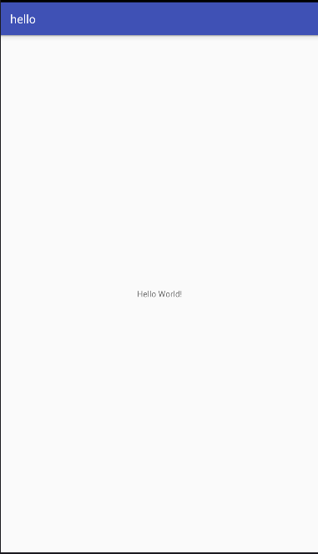

**JAVA FILE**

**package** com.example.ankit.hello;  
  
**import** android.support.v7.app.AppCompatActivity;  
**import** android.os.Bundle;  
  
**public class** MainActivity **extends** AppCompatActivity {  
  
 @Override  
 **protected void** onCreate(Bundle savedInstanceState) {  
 **super**.onCreate(savedInstanceState);  
 setContentView(R.layout.***activity_main***);  
 }  
}

**XML FILE**

*<?***xml version="1.0" encoding="utf-8"***?>*<**android.support.constraint.ConstraintLayout xmlns:android="http://schemas.android.com/apk/res/android"  
 xmlns:app="http://schemas.android.com/apk/res-auto"  
 xmlns:tools="http://schemas.android.com/tools"  
 android:layout_width="match_parent"  
 android:layout_height="match_parent"  
 tools:context=".MainActivity"**>  
  
 <**TextView  
 android:layout_width="wrap_content"  
 android:layout_height="wrap_content"  
 android:text="Hello World!"  
 app:layout_constraintBottom_toBottomOf="parent"  
 app:layout_constraintLeft_toLeftOf="parent"  
 app:layout_constraintRight_toRightOf="parent"  
 app:layout_constraintTop_toTopOf="parent"** />  
  
</**android.support.constraint.ConstraintLayout**

2. Create an application to show various android lifecycle phases.

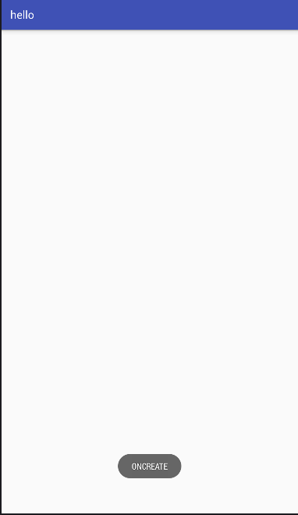

**JAVA FILE**

**package** com.example.ankit.hello;  
  
**import** android.support.v7.app.AppCompatActivity;  
**import** android.os.Bundle;  
**import** android.view.View;  
**import** android.widget.Toast;  
  
**public class** MainActivity **extends** AppCompatActivity {  
  
 @Override  
 **protected void** onCreate(Bundle savedInstanceState) {  
 **super**.onCreate(savedInstanceState);  
 setContentView(R.layout.***activity_main***);  
 Toast.*makeText*(**this**,**"ONCREATE"**,Toast.***LENGTH_LONG***).show();  
 }  
 **public void** onStart()  
 {  
 **super**.onStart();  
 Toast.*makeText*(**this**,**"ONSTART"**,Toast.***LENGTH_LONG***).show();  
 }  
 **public void** onRestart()  
 {  
 **super**.onRestart();  
 Toast.*makeText*(**this**,**"ONRESTART"**,Toast.***LENGTH_LONG***).show();  
 }  
 **public void** onPause()  
 {  
 **super**.onPause();  
 Toast.*makeText*(**this**,**"ONPAUSE"**,Toast.***LENGTH_LONG***).show();  
 }  
 **public void** onResume()  
 {  
 **super**.onResume();  
 Toast.*makeText*(**this**,**"ONRESUME"**,Toast.***LENGTH_LONG***).show();  
 }  
 **public void** onStop()  
 {  
 **super**.onStop();  
 Toast.*makeText*(**this**,**"ONSTOP"**,Toast.***LENGTH_LONG***).show();  
 }  
 **public void** onDestroy()  
 {  
 **super**.onDestroy();  
 Toast.*makeText*(**this**,**"ONDESTROY"**,Toast.***LENGTH_LONG***).show();  
 }  
  
  
}

**XML FILE**

*<?***xml version="1.0" encoding="utf-8"***?>*<**android.support.constraint.ConstraintLayout xmlns:android="http://schemas.android.com/apk/res/android"  
 xmlns:app="http://schemas.android.com/apk/res-auto"  
 xmlns:tools="http://schemas.android.com/tools"  
 android:layout_width="match_parent"  
 android:layout_height="match_parent"  
 tools:context=".MainActivity"**>  
  
</**android.support.constraint.ConstraintLayout**>

**=====================================================================================**

3. Create an application with first activity with an Edit Text and a send button. On Click of send button make us of explicit intent to send text to second activity and display message there in text view.

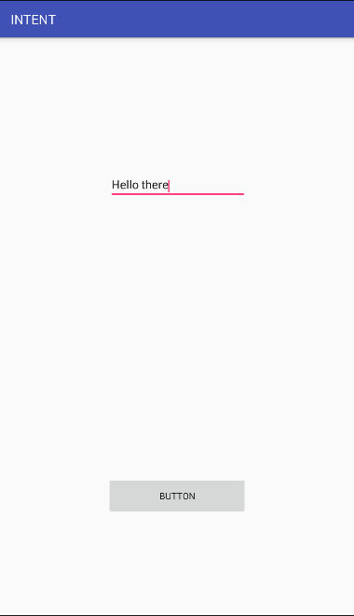

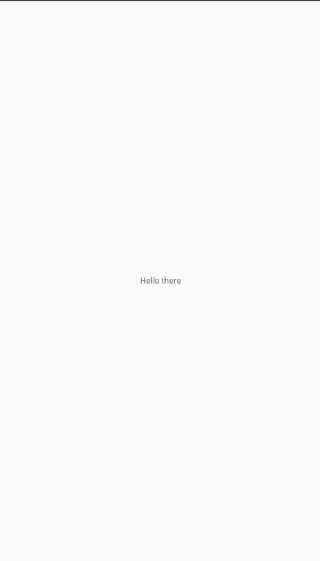

**First Activity JAVA FILE**

**package** com.example.ankit.intent;  
  
**import** android.content.Intent;  
**import** android.support.v7.app.AppCompatActivity;  
**import** android.os.Bundle;  
**import** android.view.View;  
**import** android.widget.Button;  
**import** android.widget.EditText;  
  
**public class** First **extends** AppCompatActivity {  
  
 EditText **editText**;  
 Button **button**;  
 @Override  
 **protected void** onCreate(Bundle savedInstanceState) {  
 **super**.onCreate(savedInstanceState);  
 setContentView(R.layout.***activity_first***);  
 }  
  
 **public void** send_message(View view)  
 {  
 **editText**=(EditText)findViewById(R.id.***editText***);  
 **button**=(Button)findViewById(R.id.***button***);  
  
 String string=**editText**.getText().toString();  
  
 Intent first=**new** Intent(**this**,Second.**class**);  
 first.putExtra(**"mmm"**,string);  
 startActivity(first);  
 }  
}

**First activity XML FILE**

*<?***xml version="1.0" encoding="utf-8"***?>*<**android.support.constraint.ConstraintLayout xmlns:android="http://schemas.android.com/apk/res/android"  
 xmlns:app="http://schemas.android.com/apk/res-auto"  
 xmlns:tools="http://schemas.android.com/tools"  
 android:layout_width="match_parent"  
 android:layout_height="match_parent"  
 tools:context=".First"**>  
  
 <**EditText  
 android:id="@+id/editText"  
 android:layout_width="wrap_content"  
 android:layout_height="39dp"  
 android:layout_marginBottom="8dp"  
 android:layout_marginEnd="8dp"  
 android:layout_marginLeft="8dp"  
 android:layout_marginRight="8dp"  
 android:layout_marginStart="8dp"  
 android:layout_marginTop="8dp"  
 android:ems="10"  
 android:gravity="start"  
 android:inputType="textMultiLine"  
 app:layout_constraintBottom_toBottomOf="parent"  
 app:layout_constraintEnd_toEndOf="parent"  
 app:layout_constraintHorizontal_bias="0.503"  
 app:layout_constraintStart_toStartOf="parent"  
 app:layout_constraintTop_toTopOf="parent"  
 app:layout_constraintVertical_bias="0.242"** />  
  
 <**Button  
 android:id="@+id/button"  
 android:layout_width="214dp"  
 android:layout_height="59dp"  
 android:layout_marginBottom="8dp"  
 android:layout_marginEnd="8dp"  
 android:layout_marginLeft="8dp"  
 android:layout_marginRight="8dp"  
 android:layout_marginStart="8dp"  
 android:layout_marginTop="8dp"  
 android:gravity="center"  
 android:onClick="send_message"  
 android:text="Button"  
 app:layout_constraintBottom_toBottomOf="parent"  
 app:layout_constraintEnd_toEndOf="parent"  
 app:layout_constraintStart_toStartOf="parent"  
 app:layout_constraintTop_toTopOf="parent"  
 app:layout_constraintVertical_bias="0.821"** />  
</**android.support.constraint.ConstraintLayout**>

**Second activity JAVA FILE**

**package** com.example.ankit.intent;  
  
**import** android.app.Activity;  
**import** android.content.Intent;  
**import** android.os.Bundle;  
**import** android.widget.TextView;  
  
**public class** Second **extends** Activity {  
  
 TextView **textView**;  
 @Override  
 **protected void** onCreate(Bundle savedInstanceState) {  
 **super**.onCreate(savedInstanceState);  
 setContentView(R.layout.***activity_second***);  
 Intent g=getIntent();  
 **textView**=(TextView)findViewById(R.id.***textView***);  
  
 **textView**.setText(g.getStringExtra(**"mmm"**));  
 }  
}

**Second activity XML FILE**

*<?***xml version="1.0" encoding="utf-8"***?>*<**android.support.constraint.ConstraintLayout xmlns:android="http://schemas.android.com/apk/res/android"  
 xmlns:app="http://schemas.android.com/apk/res-auto"  
 xmlns:tools="http://schemas.android.com/tools"  
 android:layout_width="match_parent"  
 android:layout_height="match_parent"  
 tools:context=".Second"**>  
  
 <**TextView  
 android:id="@+id/textView"  
 android:layout_width="wrap_content"  
 android:layout_height="wrap_content"  
 android:layout_marginBottom="275dp"  
 android:layout_marginEnd="163dp"  
 android:layout_marginLeft="163dp"  
 android:layout_marginRight="163dp"  
 android:layout_marginStart="163dp"  
 android:layout_marginTop="273dp"  
 app:layout_constraintBottom_toBottomOf="parent"  
 app:layout_constraintEnd_toEndOf="parent"  
 app:layout_constraintStart_toStartOf="parent"  
 app:layout_constraintTop_toTopOf="parent"** />  
</**android.support.constraint.ConstraintLayout**>

**=====================================================================================**

4. Create an application with first activity with an edit text and a send button. On the click of the send button , make use of implicit intent that uses a SEND ACTION and let user select app from app chooser and navigate to the application.

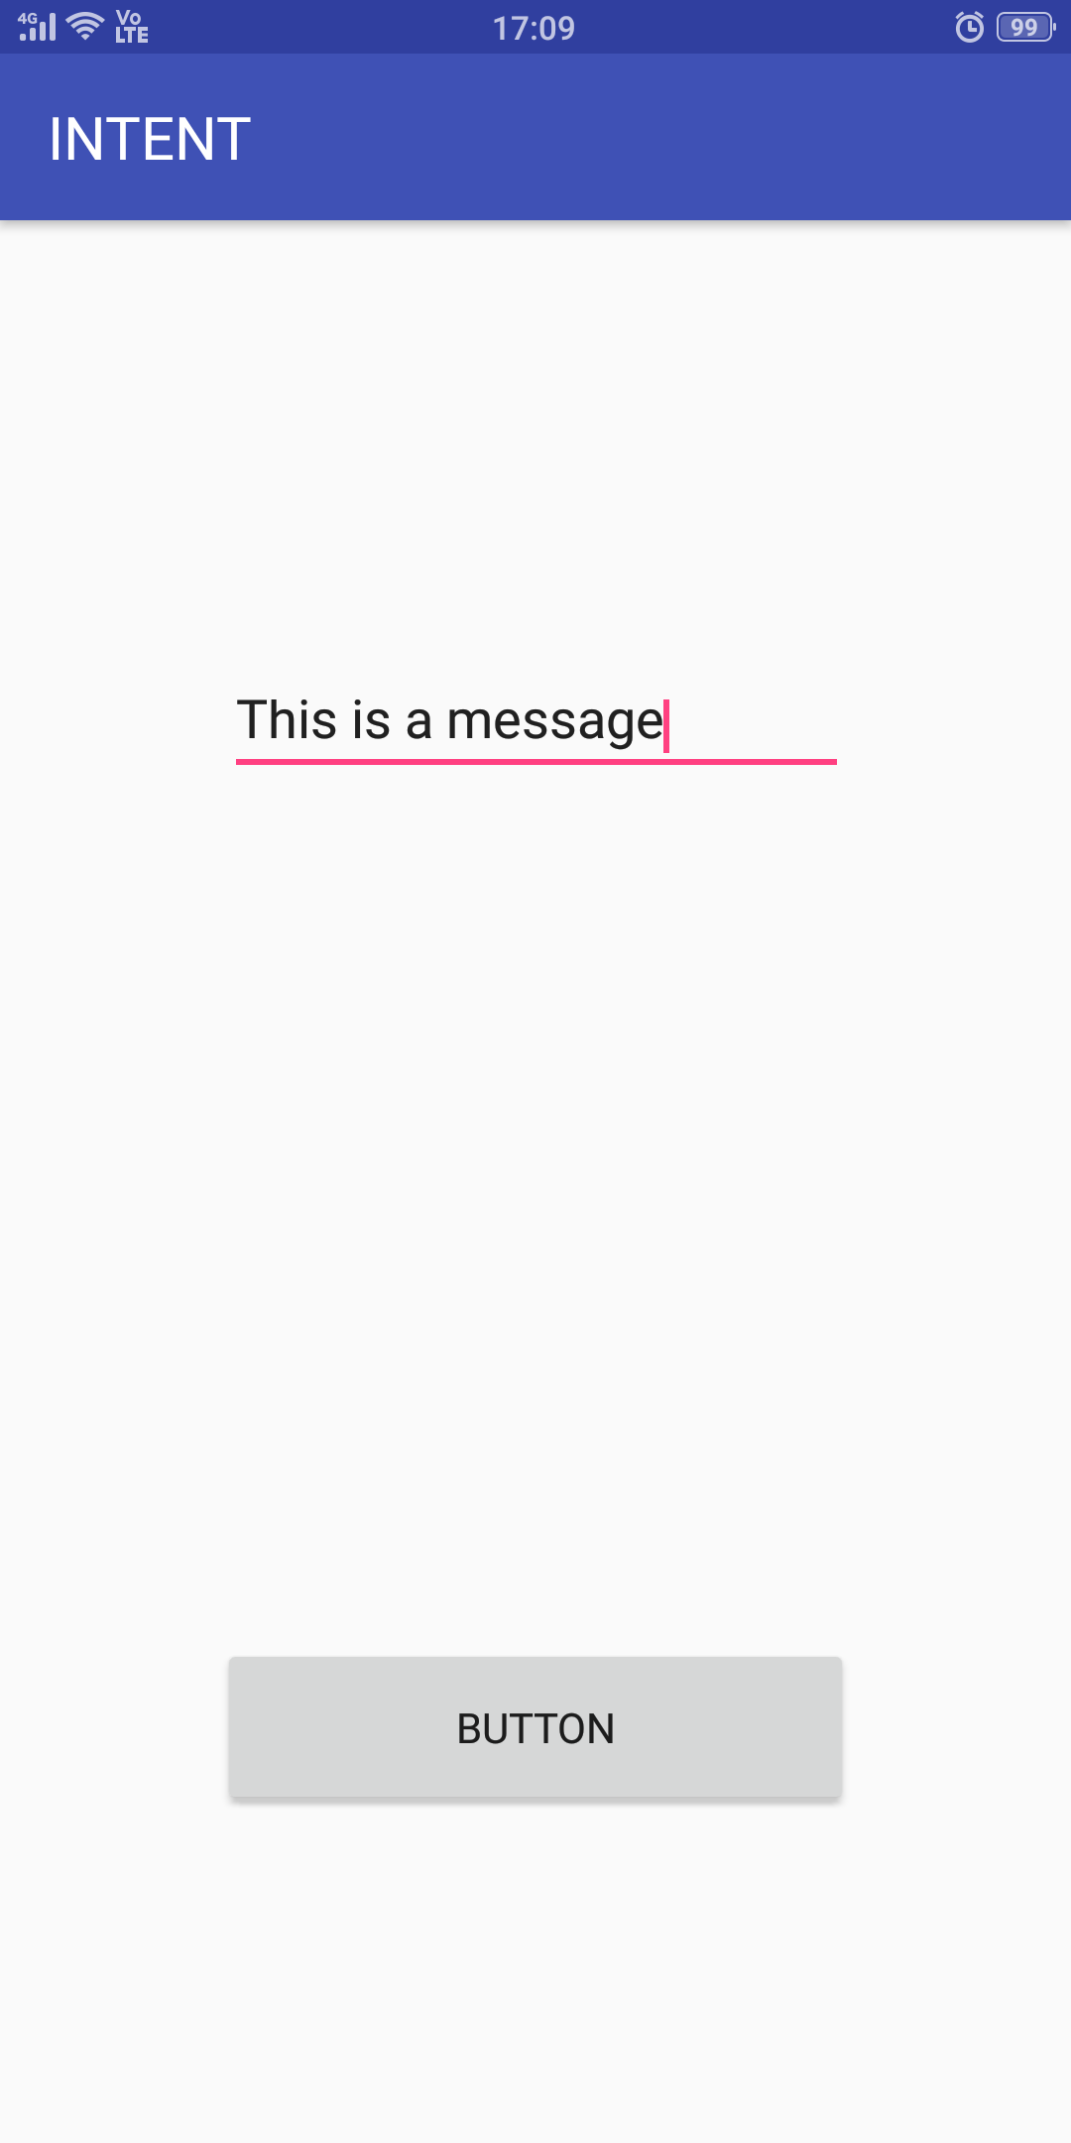

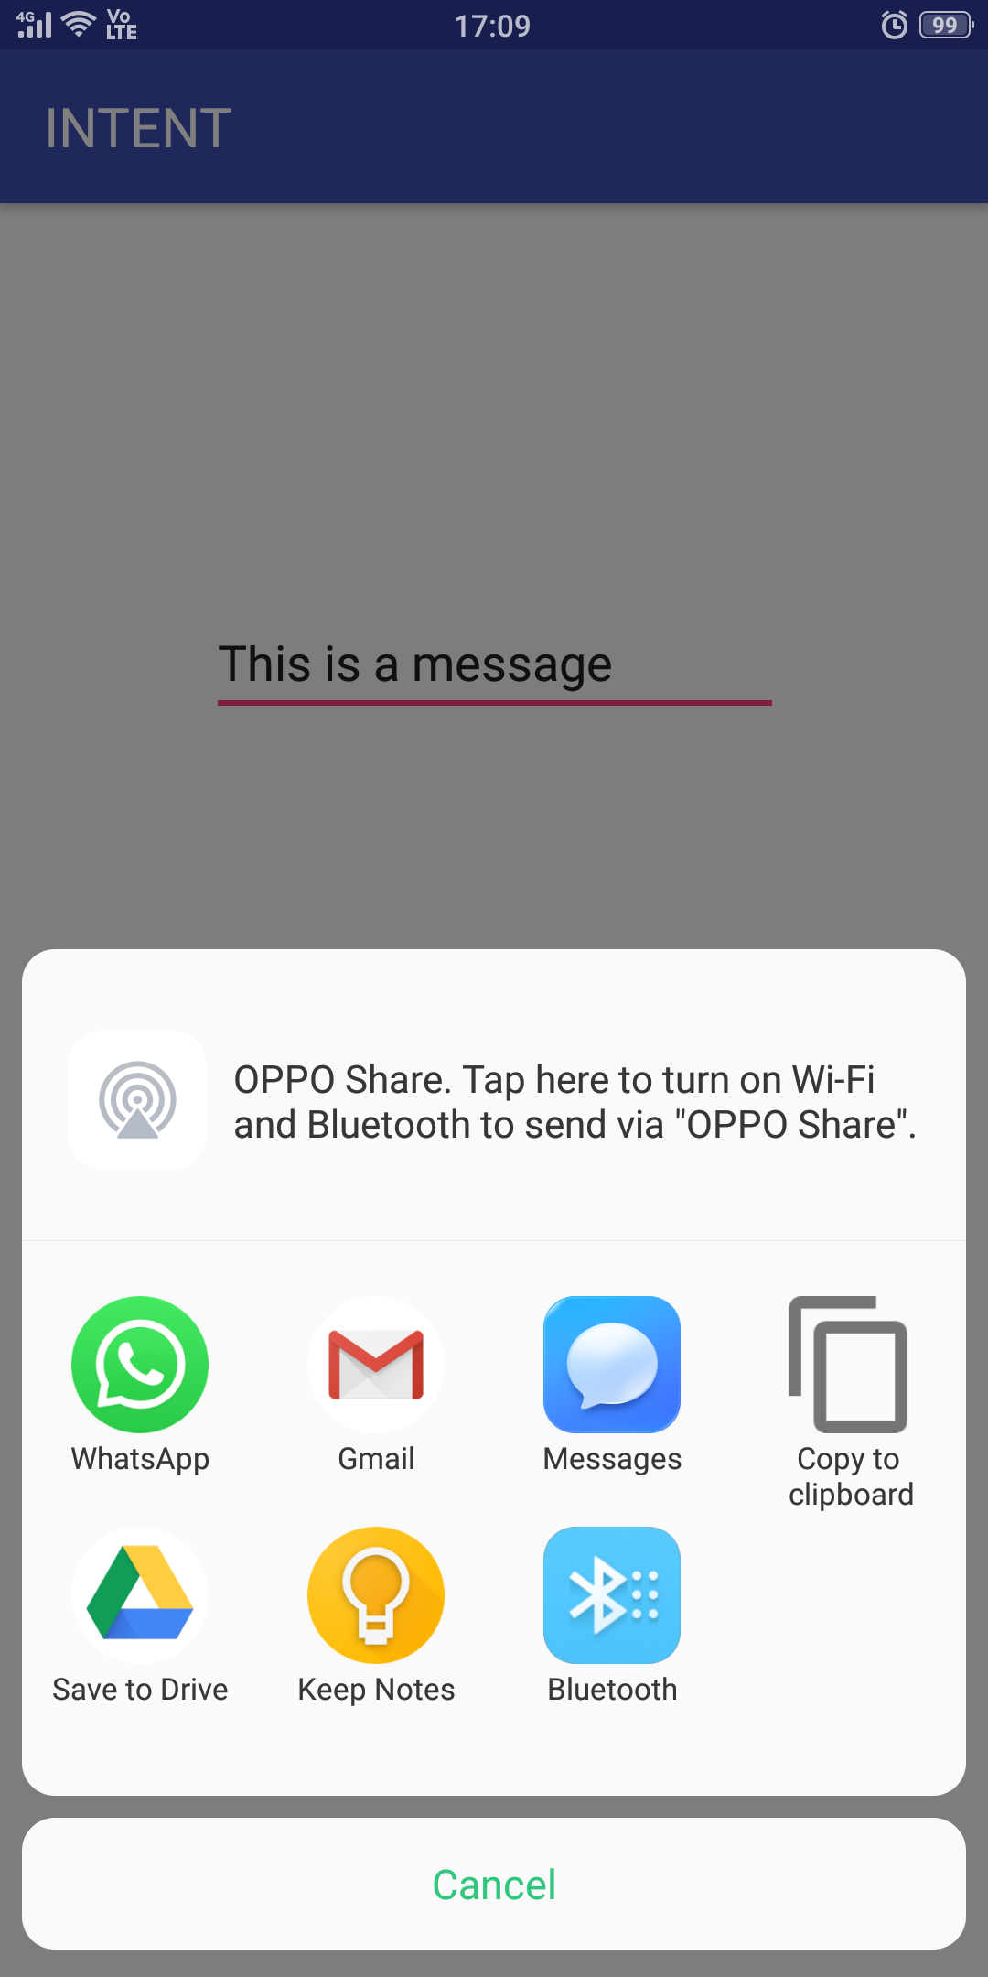

**JAVA FILE**

**package** com.example.ankit.intent;  
  
**import** android.content.Intent;  
**import** android.support.v7.app.AppCompatActivity;  
**import** android.os.Bundle;  
**import** android.view.View;  
**import** android.widget.Button;  
**import** android.widget.EditText;  
  
**public class** First **extends** AppCompatActivity {  
  
 EditText **editText**;  
 Button **button**;  
 @Override  
 **protected void** onCreate(Bundle savedInstanceState) {  
 **super**.onCreate(savedInstanceState);  
 setContentView(R.layout.***activity_first***);  
 }  
  
 **public void** send_message(View view)  
 {  
 **editText**=(EditText)findViewById(R.id.***editText***);  
 **button**=(Button)findViewById(R.id.***button***);  
  
 String string=**editText**.getText().toString();  
  
 Intent first=**new** Intent(Intent.***ACTION_SEND***);  
 first.setType(**"text/plain"**);  
 first.putExtra(Intent.***EXTRA_TEXT***,string);  
 Intent ch=Intent.*createChooser*(first,**"CHOOSE"**);  
 startActivity(ch);  
  
 startActivity(first);  
 }  
}

**XML FILE**

*<?***xml version="1.0" encoding="utf-8"***?>*<**android.support.constraint.ConstraintLayout xmlns:android="http://schemas.android.com/apk/res/android"  
 xmlns:app="http://schemas.android.com/apk/res-auto"  
 xmlns:tools="http://schemas.android.com/tools"  
 android:layout_width="match_parent"  
 android:layout_height="match_parent"  
 tools:context=".First"**>  
  
 <**EditText  
 android:id="@+id/editText"  
 android:layout_width="wrap_content"  
 android:layout_height="39dp"  
 android:layout_marginBottom="8dp"  
 android:layout_marginEnd="8dp"  
 android:layout_marginLeft="8dp"  
 android:layout_marginRight="8dp"  
 android:layout_marginStart="8dp"  
 android:layout_marginTop="8dp"  
 android:ems="10"  
 android:gravity="start"  
 android:inputType="textMultiLine"  
 app:layout_constraintBottom_toBottomOf="parent"  
 app:layout_constraintEnd_toEndOf="parent"  
 app:layout_constraintHorizontal_bias="0.503"  
 app:layout_constraintStart_toStartOf="parent"  
 app:layout_constraintTop_toTopOf="parent"  
 app:layout_constraintVertical_bias="0.242"** />  
  
 <**Button  
 android:id="@+id/button"  
 android:layout_width="214dp"  
 android:layout_height="59dp"  
 android:layout_marginBottom="8dp"  
 android:layout_marginEnd="8dp"  
 android:layout_marginLeft="8dp"  
 android:layout_marginRight="8dp"  
 android:layout_marginStart="8dp"  
 android:layout_marginTop="8dp"  
 android:gravity="center"  
 android:onClick="send_message"  
 android:text="Button"  
 app:layout_constraintBottom_toBottomOf="parent"  
 app:layout_constraintEnd_toEndOf="parent"  
 app:layout_constraintStart_toStartOf="parent"  
 app:layout_constraintTop_toTopOf="parent"  
 app:layout_constraintVertical_bias="0.821"** />  
</**android.support.constraint.ConstraintLayout**>

**=====================================================================================**

5. Create spinner with strings taken from resource folder and on changing the spinner value image will change

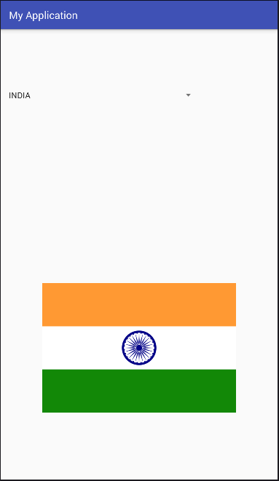

**JAVA FILE**

**package** com.example.ankit.myapplication;  
  
**import** android.support.v7.app.AppCompatActivity;  
**import** android.os.Bundle;  
**import** android.view.View;  
**import** android.widget.Adapter;  
**import** android.widget.AdapterView;  
**import** android.widget.ImageView;  
**import** android.widget.Spinner;  
**import** android.widget.TextView;  
  
**public class** SS **extends** AppCompatActivity **implements** AdapterView.OnItemSelectedListener {  
  
 Spinner **s**;  
 ImageView **iv**;  
  
 @Override  
 **protected void** onCreate(Bundle savedInstanceState) {  
 **super**.onCreate(savedInstanceState);  
 setContentView(R.layout.***activity_ss***);  
 **s** = (Spinner) findViewById(R.id.***spinner***);  
 **iv** = (ImageView) findViewById(R.id.***imageView***);  
  
 **iv**.setImageResource(R.drawable.***india***);  
 **s**.setOnItemSelectedListener(**this**);  
  
 }  
  
 @Override  
 **public void** onItemSelected(AdapterView<?> parent, View view, **int** position, **long** id) {  
  
 **if** (((TextView) view).getText().toString().trim().equals(**"INDIA"**))  
 **iv**.setImageResource(R.drawable.***india***);  
 **if** (((TextView) view).getText().toString().trim().equals(**"ITALY"**))  
 **iv**.setImageResource(R.drawable.***italy***);  
 **if** (((TextView) view).getText().toString().trim().equals(**"NEPAL"**))  
 **iv**.setImageResource(R.drawable.***nepal***);  
 **if** (((TextView) view).getText().toString().trim().equals(**"RUSSIA"**))  
 **iv**.setImageResource(R.drawable.***russia***);  
 **if** (((TextView) view).getText().toString().trim().equals(**"GERMANY"**))  
 **iv**.setImageResource(R.drawable.***germany***);  
 **if** (((TextView) view).getText().toString().trim().equals(**"FINLAND"**))  
 **iv**.setImageResource(R.drawable.***finland***);  
 **if** (((TextView) view).getText().toString().trim().equals(**"FRANCE"**))  
 **iv**.setImageResource(R.drawable.***france***);  
  
  
  
 }  
 **public void** onNothingSelected(AdapterView<?> parent) {  
  
 }  
  
}

**XML FILE**

*<?***xml version="1.0" encoding="utf-8"***?>*<**android.support.constraint.ConstraintLayout xmlns:android="http://schemas.android.com/apk/res/android"  
 xmlns:app="http://schemas.android.com/apk/res-auto"  
 xmlns:tools="http://schemas.android.com/tools"  
 android:layout_width="match_parent"  
 android:layout_height="match_parent"  
 tools:context=".SS"**>  
  
 <**Spinner  
 android:id="@+id/spinner"  
 android:layout_width="368dp"  
 android:layout_height="wrap_content"  
 android:layout_marginBottom="8dp"  
 android:layout_marginEnd="8dp"  
 android:layout_marginLeft="8dp"  
 android:layout_marginRight="8dp"  
 android:layout_marginStart="8dp"  
 android:layout_marginTop="8dp"  
 android:entries="@array/flags"  
 app:layout_constraintBottom_toBottomOf="parent"  
 app:layout_constraintEnd_toEndOf="parent"  
 app:layout_constraintHorizontal_bias="0.0"  
 app:layout_constraintStart_toStartOf="parent"  
 app:layout_constraintTop_toTopOf="parent"  
 app:layout_constraintVertical_bias="0.13"** />  
  
 <**ImageView  
 android:id="@+id/imageView"  
 android:layout_width="wrap_content"  
 android:layout_height="252dp"  
 android:layout_marginBottom="8dp"  
 android:layout_marginLeft="8dp"  
 android:layout_marginStart="8dp"  
 android:layout_marginTop="8dp"  
 app:layout_constraintBottom_toBottomOf="parent"  
 app:layout_constraintEnd_toEndOf="parent"  
 app:layout_constraintHorizontal_bias="1.0"  
 app:layout_constraintStart_toStartOf="parent"  
 app:layout_constraintTop_toTopOf="parent"  
 app:layout_constraintVertical_bias="0.799"  
 app:srcCompat="@drawable/india"** />  
</**android.support.constraint.ConstraintLayout**>

**STRING.XML**

<**resources**>  
 <**string name="app_name"**>My Application</**string**>  
 <**string-array name="flags"**>  
 <**item**>INDIA</**item**>  
 <**item**>GERMANY</**item**>  
 <**item**>FRANCE</**item**>  
 <**item**>NEPAL</**item**>  
 <**item**>ITALY</**item**>  
 <**item**>FINLAND</**item**>  
 <**item**>RUSSIA</**item**>  
  
 </**string-array**>  
</**resources**>

**=====================================================================================**

6. Create a menu with 5 options and selected option should appear in textbox.

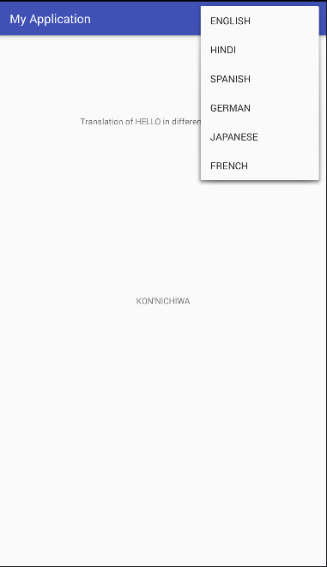

**JAVA FILE**

**package** com.example.ankit.myapplication;  
  
**import** android.support.v7.app.AppCompatActivity;  
**import** android.os.Bundle;  
**import** android.view.Menu;  
**import** android.view.MenuInflater;  
**import** android.view.MenuItem;  
**import** android.widget.TextView;  
  
**public class** ONMM **extends** AppCompatActivity {  
  
 @Override  
 **protected void** onCreate(Bundle savedInstanceState) {  
 **super**.onCreate(savedInstanceState);  
 setContentView(R.layout.***activity_onmm***);  
 }  
 **public boolean** onCreateOptionsMenu(Menu m)  
 {  
 MenuInflater mi=getMenuInflater();  
 mi.inflate(R.menu.***menuu***,m);  
 **return true**;  
 }  
 **public boolean** onOptionsItemSelected(MenuItem im)  
 {  
 TextView tv=findViewById(R.id.***textView2***);  
 **switch**(im.getItemId())  
 {  
 **case** R.id.***eng***:tv.setText(**"HELLO"**);  
 **break**;  
 **case** R.id.***hin***:tv.setText(**"NAMASTE"**);  
 **break**;  
 **case** R.id.***spa***:tv.setText(**"HOLA"**);  
 **break**;  
 **case** R.id.***fre***:tv.setText(**"BON JOUR"**);  
 **break**;  
 **case** R.id.***jap***:tv.setText(**"KON'NICHIWA"**);  
 **break**;  
 **case** R.id.***ger***:tv.setText(**"HALLO"**);  
 **break**;  
  
 }  
 **return true**;  
  
 }  
}

**MENU FILE**

*<?***xml version="1.0" encoding="utf-8"***?>*<**menu xmlns:app="http://schemas.android.com/apk/res-auto"  
 xmlns:android="http://schemas.android.com/apk/res/android"**>  
  
 <**item  
 android:id="@+id/eng"  
 android:title="ENGLISH"** />  
 <**item  
 android:id="@+id/hin"  
 android:title="HINDI"** />  
 <**item  
 android:id="@+id/spa"  
 android:title="SPANISH"** />  
 <**item  
 android:id="@+id/ger"  
 android:title="GERMAN"** />  
 <**item  
 android:id="@+id/jap"  
 android:title="JAPANESE"** />  
 <**item  
 android:id="@+id/fre"  
 android:title="FRENCH"** />  
</**menu**>

**XML FILE**

*<?***xml version="1.0" encoding="utf-8"***?>*<**android.support.constraint.ConstraintLayout xmlns:android="http://schemas.android.com/apk/res/android"  
 xmlns:app="http://schemas.android.com/apk/res-auto"  
 xmlns:tools="http://schemas.android.com/tools"  
 android:layout_width="match_parent"  
 android:layout_height="match_parent"  
 tools:context=".ONMM"**>  
  
 <**TextView  
 android:id="@+id/textView2"  
 android:layout_width="wrap_content"  
 android:layout_height="wrap_content"  
 android:layout_marginBottom="8dp"  
 android:layout_marginEnd="8dp"  
 android:layout_marginLeft="8dp"  
 android:layout_marginRight="8dp"  
 android:layout_marginStart="8dp"  
 android:layout_marginTop="8dp"  
 app:layout_constraintBottom_toBottomOf="parent"  
 app:layout_constraintEnd_toEndOf="parent"  
 app:layout_constraintStart_toStartOf="parent"  
 app:layout_constraintTop_toTopOf="parent"** />  
  
 <**TextView  
 android:id="@+id/textView3"  
 android:layout_width="wrap_content"  
 android:layout_height="wrap_content"  
 android:layout_marginBottom="8dp"  
 android:layout_marginEnd="8dp"  
 android:layout_marginLeft="8dp"  
 android:layout_marginRight="8dp"  
 android:layout_marginStart="8dp"  
 android:layout_marginTop="8dp"  
 android:text="Translation of HELLO in different languages"  
 app:layout_constraintBottom_toBottomOf="parent"  
 app:layout_constraintEnd_toEndOf="parent"  
 app:layout_constraintStart_toStartOf="parent"  
 app:layout_constraintTop_toTopOf="parent"  
 app:layout_constraintVertical_bias="0.148"  
 tools:fontFamily="serif"  
 tools:textSize="18sp"** />  
</**android.support.constraint.ConstraintLayout**>

**=====================================================================================**

7. Create a RadioGroup with RadioButton of courses in your college and on selecting a radiobutton the name of teacher-in-charge of the course should appear in the bottom in the screeen.

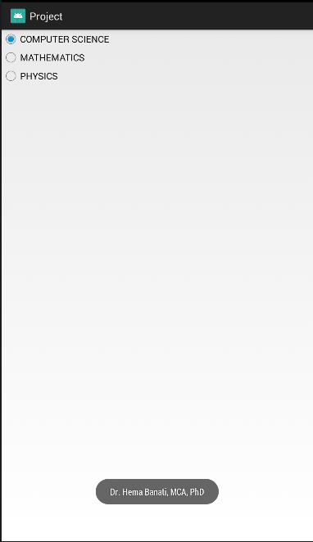

**JAVA FILE**

**package** com.example.ankit.project;  
  
**import** android.app.Activity;  
**import** android.os.Bundle;  
**import** android.view.View;  
**import** android.widget.RadioGroup;  
**import** android.widget.Toast;  
  
**public class** MainActivity **extends** Activity {  
 RadioGroup **rgrg**;  
 @Override  
 **protected void** onCreate(Bundle savedInstanceState) {  
 **super**.onCreate(savedInstanceState);  
 setContentView(R.layout.***activity_main***);  
 }  
 **public void** onCL(View v)  
 {  
 **rgrg**=(RadioGroup)findViewById(R.id.***rg***);  
 **int** i=**rgrg**.getCheckedRadioButtonId();  
 String msg=**""**;  
 **switch**(i)  
 {  
 **case** R.id.***ma***:msg=**"Ms. Rajni Kulshreshta, MA, MPhil"**;  
 **break**;  
 **case** R.id.***cs***:msg=**"Dr. Hema Banati, MCA, PhD"**;  
 **break**;  
 **case** R.id.***py***:msg=**"Dr. Jagjiwan Ram Balai, MSc, PhD"**;  
 **break**;  
 }  
 Toast.*makeText*(**this**,msg,Toast.***LENGTH_LONG***).show();  
  
 }  
}

**XML FILE**

*<?***xml version="1.0" encoding="utf-8"***?>*<**android.support.constraint.ConstraintLayout xmlns:android="http://schemas.android.com/apk/res/android"  
 xmlns:app="http://schemas.android.com/apk/res-auto"  
 xmlns:tools="http://schemas.android.com/tools"  
 android:layout_width="match_parent"  
 android:layout_height="match_parent"  
 tools:context=".MainActivity"**>  
  
  
 <**RadioGroup  
 android:layout_width="wrap_content"  
 android:layout_height="wrap_content"  
 android:id="@+id/rg"** >  
 <**RadioButton  
 android:layout_width="wrap_content"  
 android:layout_height="wrap_content"  
 android:text="COMPUTER SCIENCE"  
 android:id="@+id/cs"  
 android:onClick="onCL"** />  
 <**RadioButton  
 android:layout_width="wrap_content"  
 android:layout_height="wrap_content"  
 android:text="MATHEMATICS"  
 android:id="@+id/ma"  
 android:onClick="onCL"** />  
 <**RadioButton  
 android:layout_width="wrap_content"  
 android:layout_height="wrap_content"  
 android:text="PHYSICS"  
 android:id="@+id/py"  
 android:onClick="onCL"** />  
  
 </**RadioGroup**>  
</**android.support.constraint.ConstraintLayout**>

**=====================================================================================**

8. Create an application with three buttons vertically aligned and on selecting a button, the color of the screen will change.

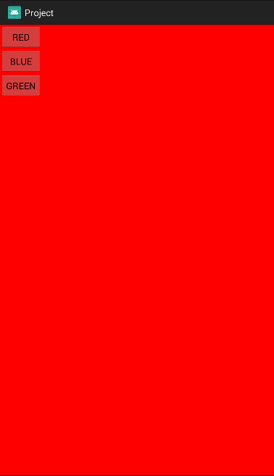

**JAVA FILE**

**package** com.example.ankit.project;  
  
**import** android.app.Activity;  
**import** android.graphics.Color;  
**import** android.os.Bundle;  
**import** android.view.View;  
**import** android.widget.Button;  
**import** android.widget.RadioGroup;  
**import** android.widget.Toast;  
  
**public class** MainActivity **extends** Activity {  
 Button **r**,**b**,**g**;  
 @Override  
 **protected void** onCreate(Bundle savedInstanceState) {  
 **super**.onCreate(savedInstanceState);  
 setContentView(R.layout.***activity_main***);  
 }  
 **public void** onClick(View v)  
 {  
 **int** id=v.getId();  
  
 **switch**(id)  
 {  
 **case** R.id.***button***:getWindow().getDecorView().setBackgroundColor(Color.***RED***);  
 **break**;  
 **case** R.id.***button2***:getWindow().getDecorView().setBackgroundColor(Color.***BLUE***);  
 **break**;  
 **case** R.id.***button3***:getWindow().getDecorView().setBackgroundColor(Color.***GREEN***);  
 **break**;  
 }  
 }  
  
  
}

**XML FILE**

*<?***xml version="1.0" encoding="utf-8"***?>*<**LinearLayout  
 xmlns:android="http://schemas.android.com/apk/res/android"  
 android:layout_height="wrap_content"  
 android:layout_width="wrap_content"  
 android:orientation="vertical"** >  
  
 <**Button  
 android:id="@+id/button"  
 android:layout_width="match_parent"  
 android:layout_height="wrap_content"  
 android:onClick="onClick"  
 android:text="RED"** />  
  
 <**Button  
 android:id="@+id/button2"  
 android:layout_width="match_parent"  
 android:layout_height="wrap_content"  
 android:onClick="onClick"  
 android:text="BLUE"** />  
  
 <**Button  
 android:id="@+id/button3"  
 android:layout_width="match_parent"  
 android:onClick="onClick"  
 android:layout_height="wrap_content"  
 android:text="GREEN"** />  
  
</**LinearLayout**>

**=====================================================================================**

9. Create an application with three buttons horizontally aligned and on selecting a button, the color of the screen will change.

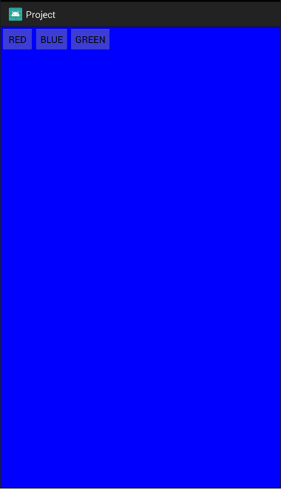

**JAVA FILE**

**package** com.example.ankit.project;  
  
**import** android.app.Activity;  
**import** android.graphics.Color;  
**import** android.os.Bundle;  
**import** android.view.View;  
**import** android.widget.Button;  
**import** android.widget.RadioGroup;  
**import** android.widget.Toast;  
  
**public class** MainActivity **extends** Activity {  
 Button **r**,**b**,**g**;  
 @Override  
 **protected void** onCreate(Bundle savedInstanceState) {  
 **super**.onCreate(savedInstanceState);  
 setContentView(R.layout.***activity_main***);  
 }  
 **public void** onClick(View v)  
 {  
 **int** id=v.getId();  
  
 **switch**(id)  
 {  
 **case** R.id.***button***:getWindow().getDecorView().setBackgroundColor(Color.***RED***);  
 **break**;  
 **case** R.id.***button2***:getWindow().getDecorView().setBackgroundColor(Color.***BLUE***);  
 **break**;  
 **case** R.id.***button3***:getWindow().getDecorView().setBackgroundColor(Color.***GREEN***);  
 **break**;  
 }  
 }  
  
  
}

**XML FILE**

*<?***xml version="1.0" encoding="utf-8"***?>*<**LinearLayout  
 xmlns:android="http://schemas.android.com/apk/res/android"  
 android:layout_height="wrap_content"  
 android:layout_width="wrap_content"  
 android:orientation="horizontal"** >  
  
 <**Button  
 android:id="@+id/button"  
 android:layout_width="match_parent"  
 android:layout_height="wrap_content"  
 android:onClick="onClick"  
 android:text="RED"** />  
  
 <**Button  
 android:id="@+id/button2"  
 android:layout_width="match_parent"  
 android:layout_height="wrap_content"  
 android:onClick="onClick"  
 android:text="BLUE"** />  
  
 <**Button  
 android:id="@+id/button3"  
 android:layout_width="match_parent"  
 android:onClick="onClick"  
 android:layout_height="wrap_content"  
 android:text="GREEN"** />  
  
</**LinearLayout**>

**=====================================================================================**

10. Create a login application(Check username and password). On successful login, pop us the message ("Welcome Username").

**JAVA FILE**

**package** com.example.ankit.project;  
  
**import** android.app.Activity;  
**import** android.graphics.Color;  
**import** android.os.Bundle;  
**import** android.view.View;  
**import** android.widget.Button;  
**import** android.widget.EditText;  
**import** android.widget.RadioGroup;  
**import** android.widget.Toast;  
  
**public class** MainActivity **extends** Activity {  
  
 EditText **u**,**p**;  
 @Override  
 **protected void** onCreate(Bundle savedInstanceState) {  
 **super**.onCreate(savedInstanceState);  
 setContentView(R.layout.***activity_main***);  
 }  
  
 **public void** onClick(View v)  
 {  
 **u**=findViewById(R.id.***editText2***);  
 **p**=findViewById(R.id.***editText3***);  
  
 String s1=**u**.getText().toString();  
 String s2=**p**.getText().toString();  
  
 **if**(s1.equals(s1)&&s2.equals(**"Password"**))  
 Toast.*makeText*(**this**,**"Welcome "**+s1,Toast.***LENGTH_LONG***).show();  
 **else** Toast.*makeText*(**this**,**"EITHER OF THE FIELD IS INCORRECT"**,Toast.***LENGTH_LONG***).show();  
 }  
  
}

**XML FILE**

*<?***xml version="1.0" encoding="utf-8"***?>*<**android.support.constraint.ConstraintLayout  
  
  
 xmlns:android="http://schemas.android.com/apk/res/android"  
 xmlns:app="http://schemas.android.com/apk/res-auto"  
 xmlns:tools="http://schemas.android.com/tools"  
 android:layout_height="match_parent"  
 android:layout_width="match_parent"** >  
  
  
 <**EditText  
 android:id="@+id/editText3"  
 android:layout_width="wrap_content"  
 android:layout_height="wrap_content"  
 android:layout_marginBottom="8dp"  
 android:layout_marginEnd="8dp"  
 android:layout_marginLeft="8dp"  
 android:layout_marginRight="8dp"  
 android:layout_marginStart="8dp"  
 android:layout_marginTop="8dp"  
 android:ems="10"  
 android:hint="Password"  
 android:inputType="textPersonName"  
 app:layout_constraintBottom_toBottomOf="parent"  
 app:layout_constraintEnd_toEndOf="parent"  
 app:layout_constraintHorizontal_bias="0.444"  
 app:layout_constraintStart_toStartOf="parent"  
 app:layout_constraintTop_toTopOf="parent"  
 app:layout_constraintVertical_bias="0.384"** />  
  
 <**EditText  
 android:id="@+id/editText2"  
 android:layout_width="wrap_content"  
 android:layout_height="wrap_content"  
 android:layout_marginBottom="8dp"  
 android:layout_marginEnd="8dp"  
 android:layout_marginLeft="8dp"  
 android:layout_marginRight="8dp"  
 android:layout_marginStart="8dp"  
 android:layout_marginTop="8dp"  
 android:ems="10"  
 android:hint="Username"  
 android:inputType="textPersonName"  
 app:layout_constraintBottom_toBottomOf="parent"  
 app:layout_constraintEnd_toEndOf="parent"  
 app:layout_constraintHorizontal_bias="0.444"  
 app:layout_constraintStart_toStartOf="parent"  
 app:layout_constraintTop_toTopOf="parent"  
 app:layout_constraintVertical_bias="0.22"** />  
  
 <**Button  
 android:id="@+id/button4"  
 android:layout_width="wrap_content"  
 android:layout_height="wrap_content"  
 android:layout_marginBottom="8dp"  
 android:layout_marginEnd="8dp"  
 android:layout_marginLeft="8dp"  
 android:layout_marginRight="8dp"  
 android:layout_marginStart="8dp"  
 android:layout_marginTop="40dp"  
 android:onClick="onClick"  
 android:text="LOGIN"  
 app:layout_constraintBottom_toBottomOf="parent"  
 app:layout_constraintEnd_toEndOf="parent"  
 app:layout_constraintHorizontal_bias="0.46"  
 app:layout_constraintStart_toStartOf="parent"  
 app:layout_constraintTop_toTopOf="parent"  
 app:layout_constraintVertical_bias="0.562"** />  
</**android.support.constraint.ConstraintLayout**>

**=====================================================================================**

11.Create a login application as above, on successful login redirect to another activity with logout button. On Click of logout button a dialog appears with OK and CANCEL button. On OK button click go to login activity and on CANCEL stay at same activity.

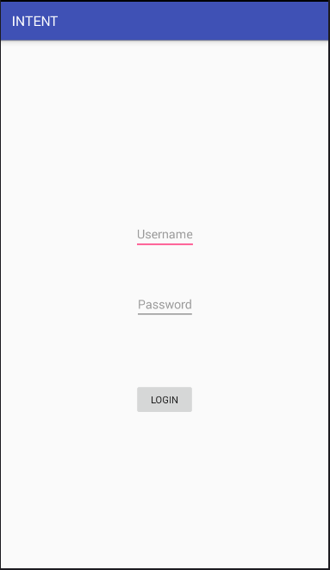

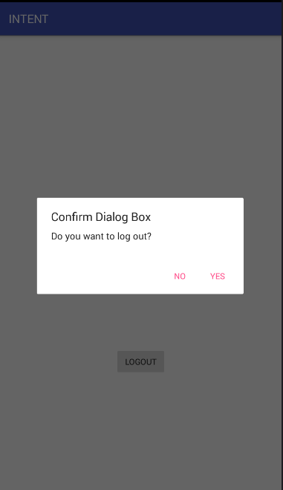

**Main JAVA FILE**

**package** com.example.ankit.intent;  
  
**import** android.content.Intent;  
**import** android.support.v7.app.AppCompatActivity;  
**import** android.os.Bundle;  
**import** android.view.View;  
**import** android.widget.Button;  
**import** android.widget.EditText;  
**import** android.widget.Toast;  
  
**public class** First **extends** AppCompatActivity {  
  
 EditText **editText1**,**editText2**;  
 Button **button**;  
 @Override  
 **protected void** onCreate(Bundle savedInstanceState) {  
 **super**.onCreate(savedInstanceState);  
 setContentView(R.layout.***activity_first***);  
 }  
  
 **public void** onLogin(View view)  
 {  
 **editText1**=(EditText)findViewById(R.id.***uname***);  
 **editText2**=(EditText)findViewById(R.id.***pword***);  
  
 String u=**editText1**.getText().toString();  
 String p=**editText2**.getText().toString();  
  
 **if**(u.equals(u)&&p.equals(**"Password"**))  
 {  
 Intent intent=**new** Intent(**this**,scond.**class**);  
 intent.putExtra(**"username"**,u);  
  
 startActivity(intent);  
 }  
 **else** {  
 Toast.*makeText*(**this**,**"Either of the field is incorrect!"**,Toast.***LENGTH_SHORT***).show();  
 }  
 }  
  
  
}

**Main XML FILE**

*<?***xml version="1.0" encoding="utf-8"***?>*<**android.support.constraint.ConstraintLayout xmlns:android="http://schemas.android.com/apk/res/android"  
 xmlns:app="http://schemas.android.com/apk/res-auto"  
 xmlns:tools="http://schemas.android.com/tools"  
 android:layout_width="match_parent"  
 android:layout_height="match_parent"  
 tools:context=".First"**>  
  
 <**EditText  
 android:id="@+id/uname"  
 android:layout_width="wrap_content"  
 android:layout_height="wrap_content"  
 android:layout_marginBottom="8dp"  
 android:layout_marginEnd="8dp"  
 android:layout_marginLeft="8dp"  
 android:layout_marginRight="8dp"  
 android:layout_marginStart="8dp"  
 android:layout_marginTop="8dp"  
 android:hint="Username"  
 app:layout_constraintBottom_toBottomOf="parent"  
 app:layout_constraintEnd_toEndOf="parent"  
 app:layout_constraintHorizontal_bias="0.501"  
 app:layout_constraintStart_toStartOf="parent"  
 app:layout_constraintTop_toTopOf="parent"  
 app:layout_constraintVertical_bias="0.356"** />  
  
 <**EditText  
 android:id="@+id/pword"  
 android:layout_width="wrap_content"  
 android:layout_height="wrap_content"  
 android:layout_marginBottom="8dp"  
 android:layout_marginEnd="8dp"  
 android:layout_marginLeft="8dp"  
 android:layout_marginRight="8dp"  
 android:layout_marginStart="8dp"  
 android:layout_marginTop="8dp"  
 android:hint="Password"  
 app:layout_constraintBottom_toBottomOf="parent"  
 app:layout_constraintEnd_toEndOf="parent"  
 app:layout_constraintStart_toStartOf="parent"  
 app:layout_constraintTop_toTopOf="parent"** />  
  
 <**Button  
 android:id="@+id/btn"  
 android:layout_width="wrap_content"  
 android:layout_height="wrap_content"  
 android:layout_marginBottom="8dp"  
 android:layout_marginEnd="8dp"  
 android:layout_marginLeft="8dp"  
 android:layout_marginRight="8dp"  
 android:layout_marginStart="8dp"  
 android:layout_marginTop="8dp"  
 android:onClick="onLogin"  
 android:text="LOGIN"  
 app:layout_constraintBottom_toBottomOf="parent"  
 app:layout_constraintEnd_toEndOf="parent"  
 app:layout_constraintStart_toStartOf="parent"  
 app:layout_constraintTop_toTopOf="parent"  
 app:layout_constraintVertical_bias="0.697"** />  
  
  
</**android.support.constraint.ConstraintLayout**>

**Second Activity JAVA FILE**

**package** com.example.ankit.intent;  
  
**import** android.content.DialogInterface;  
**import** android.content.Intent;  
**import** android.support.v7.app.AlertDialog;  
**import** android.support.v7.app.AppCompatActivity;  
**import** android.os.Bundle;  
**import** android.view.View;  
**import** android.widget.TextView;  
**import** android.widget.Toast;  
  
**import** org.w3c.dom.Text;  
  
**public class** scond **extends** AppCompatActivity {  
  
 TextView **textView**;  
 @Override  
 **protected void** onCreate(Bundle savedInstanceState) {  
 **super**.onCreate(savedInstanceState);  
 setContentView(R.layout.***activity_scond***);  
 **textView**=findViewById(R.id.***textView2***);  
 Intent f=getIntent();  
 String d=f.getStringExtra(**"username"**);  
 **textView**.setText(**"Hello "**+d);  
 Toast.*makeText*(**this**,**"Login Successful"**,Toast.***LENGTH_LONG***).show();  
  
 }  
 **public void** onCL(View v)  
 {  
 AlertDialog.Builder dbox=**new** AlertDialog.Builder(**this**);  
 dbox.setTitle(**"Confirm Dialog Box"**);  
 dbox.setMessage(**"Do you want to log out?"**);  
 dbox.setPositiveButton(**"YES"**, **new** DialogInterface.OnClickListener() {  
 @Override  
 **public void** onClick(DialogInterface dialog, **int** which) {  
 Intent i=**new** Intent(getApplicationContext(),First.**class**);  
 startActivity(i);  
 }  
 });  
 dbox.setNegativeButton(**"NO"**, **new** DialogInterface.OnClickListener() {  
 @Override  
 **public void** onClick(DialogInterface dialog, **int** which) {  
 Toast.*makeText*(getApplicationContext(), **"Application not exited"** , Toast.***LENGTH_SHORT***).show();  
 }  
 });  
 dbox.show();  
 }  
}

**Second Activity XML FILE**

*<?***xml version="1.0" encoding="utf-8"***?>*<**android.support.constraint.ConstraintLayout xmlns:android="http://schemas.android.com/apk/res/android"  
 xmlns:app="http://schemas.android.com/apk/res-auto"  
 xmlns:tools="http://schemas.android.com/tools"  
 android:layout_width="match_parent"  
 android:layout_height="match_parent"  
 tools:context=".scond"**>  
  
 <**TextView  
 android:id="@+id/textView2"  
 android:layout_width="wrap_content"  
 android:layout_height="wrap_content"  
 android:layout_marginBottom="8dp"  
 android:layout_marginEnd="8dp"  
 android:layout_marginLeft="8dp"  
 android:layout_marginRight="8dp"  
 android:layout_marginStart="8dp"  
 android:layout_marginTop="8dp"  
 android:text="Login Successful"  
 app:layout_constraintBottom_toBottomOf="parent"  
 app:layout_constraintEnd_toEndOf="parent"  
 app:layout_constraintStart_toStartOf="parent"  
 app:layout_constraintTop_toTopOf="parent"** />  
  
 <**Button  
 android:id="@+id/button"  
 android:layout_width="wrap_content"  
 android:layout_height="wrap_content"  
 android:layout_marginBottom="8dp"  
 android:layout_marginEnd="8dp"  
 android:layout_marginLeft="8dp"  
 android:layout_marginRight="8dp"  
 android:layout_marginStart="8dp"  
 android:layout_marginTop="8dp"  
 android:text="Logout"  
 android:onClick="onCL"  
 app:layout_constraintBottom_toBottomOf="parent"  
 app:layout_constraintEnd_toEndOf="parent"  
 app:layout_constraintHorizontal_bias="0.501"  
 app:layout_constraintStart_toStartOf="parent"  
 app:layout_constraintTop_toTopOf="parent"  
 app:layout_constraintVertical_bias="0.737"** />  
</**android.support.constraint.ConstraintLayout**>

**=====================================================================================**

12. Create an application to Create, Insert, Update and Delete operation on the DataBase.

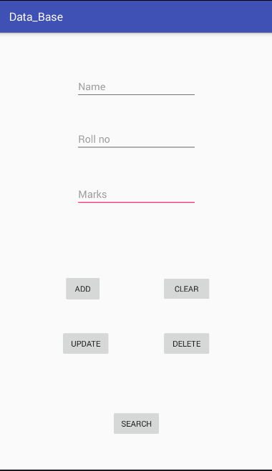

**JAVA FILE OF MAIN CLASS**

**package** com.example.ankit.data_base;  
  
**import** android.content.Intent;  
**import** android.database.Cursor;  
**import** android.support.v7.app.AppCompatActivity;  
**import** android.os.Bundle;  
**import** android.view.View;  
**import** android.widget.EditText;  
**import** android.widget.ListView;  
**import** android.widget.Toast;  
  
**public class** MainActivity **extends** AppCompatActivity {  
  
 EditText **names**, **rno**, **marks**;  
 DATA_BASE **dbs**;  
 @Override  
 **protected void** onCreate(Bundle savedInstanceState) {  
 **super**.onCreate(savedInstanceState);  
 setContentView(R.layout.***activity_main***);  
 **names** = (EditText) findViewById(R.id.***name***);  
 **rno** = (EditText) findViewById(R.id.***rno***);  
 **marks** = (EditText) findViewById(R.id.***mks***);  
 **dbs** = **new** DATA_BASE(**this**);  
 }  
  
  
 ListView **all**;  
 **public void** addstudent(View v) {  
 **dbs**.addStudent(Integer.*parseInt*(**rno**.getText().toString()), **names**.getText().toString(),  
 Integer.*parseInt*(**marks**.getText().toString()));  
 clear(v);  
 }  
 **public void** searchstudent(View v) {  
 String s = **rno**.getText().toString();  
 **int** val;  
 **if** (s.contains(**" "**))  
 val = -1;  
 **else** val = Integer.*parseInt*(s);  
 Cursor c = **dbs**.searchStudent(val);  
 **if** (c.moveToFirst()) {  
 **names**.setText(c.getString(1));  
 **marks**.setText(Integer.*toString*(c.getInt(2)));  
 } **else** {  
 **rno**.setText(**" "**);  
 **names**.setText(**" "**);  
 **marks**.setText(**" "**);  
 Toast.*makeText*(**this**, **"No Data found"**, Toast.***LENGTH_SHORT***).show();  
 }  
 }  
 **public void** deletestudent(View v) {  
 **dbs**.deleteStudent(Integer.*parseInt*(**rno**.getText().toString()));  
 clear(v);  
 }  
 **public void** update(View v) {  
 **dbs**.updateStudent(Integer.*parseInt*(**rno**.getText().toString()), **names**.getText().toString(),  
 Integer.*parseInt*(**marks**.getText().toString()));  
 clear(v);  
 }  
 **public void** clear(View v) {  
 **rno**.setText(**""**);  
 **names**.setText(**""**);  
 **marks**.setText(**""**);  
 }  
}

**XML FILE**

*<?***xml version="1.0" encoding="utf-8"***?>*<**android.support.constraint.ConstraintLayout  
 xmlns:android="http://schemas.android.com/apk/res/android"  
 xmlns:app="http://schemas.android.com/apk/res-auto"  
 xmlns:tools="http://schemas.android.com/tools"  
 android:layout_width="match_parent"  
 android:layout_height="match_parent"  
 tools:context=".MainActivity"**>  
  
 <**EditText  
 android:id="@+id/name"  
 android:layout_width="wrap_content"  
 android:layout_height="wrap_content"  
 android:layout_marginBottom="8dp"  
 android:layout_marginEnd="8dp"  
 android:layout_marginLeft="8dp"  
 android:layout_marginRight="8dp"  
 android:layout_marginStart="8dp"  
 android:layout_marginTop="8dp"  
 android:ems="10"  
 android:hint="Name"  
 android:inputType="textPersonName"  
 app:layout_constraintBottom_toBottomOf="parent"  
 app:layout_constraintEnd_toEndOf="parent"  
 app:layout_constraintHorizontal_bias="0.503"  
 app:layout_constraintStart_toStartOf="parent"  
 app:layout_constraintTop_toTopOf="parent"  
 app:layout_constraintVertical_bias="0.091"** />  
  
 <**EditText  
 android:id="@+id/rno"  
 android:layout_width="wrap_content"  
 android:layout_height="wrap_content"  
 android:layout_marginBottom="8dp"  
 android:layout_marginEnd="8dp"  
 android:layout_marginLeft="8dp"  
 android:layout_marginRight="8dp"  
 android:layout_marginStart="8dp"  
 android:layout_marginTop="8dp"  
 android:ems="10"  
 android:hint="Roll no"  
 android:inputType="textPersonName"  
 app:layout_constraintBottom_toBottomOf="parent"  
 app:layout_constraintEnd_toEndOf="parent"  
 app:layout_constraintHorizontal_bias="0.503"  
 app:layout_constraintStart_toStartOf="parent"  
 app:layout_constraintTop_toTopOf="parent"  
 app:layout_constraintVertical_bias="0.221"** />  
  
 <**EditText  
 android:id="@+id/mks"  
 android:layout_width="wrap_content"  
 android:layout_height="wrap_content"  
 android:layout_marginBottom="8dp"  
 android:layout_marginEnd="8dp"  
 android:layout_marginLeft="8dp"  
 android:layout_marginRight="8dp"  
 android:layout_marginStart="8dp"  
 android:layout_marginTop="8dp"  
 android:ems="10"  
 android:hint="Marks"  
 android:inputType="textPersonName"  
 app:layout_constraintBottom_toBottomOf="parent"  
 app:layout_constraintEnd_toEndOf="parent"  
 app:layout_constraintHorizontal_bias="0.503"  
 app:layout_constraintStart_toStartOf="parent"  
 app:layout_constraintTop_toTopOf="parent"  
 app:layout_constraintVertical_bias="0.358"** />  
  
 <**Button  
 android:id="@+id/button"  
 android:layout_width="67dp"  
 android:layout_height="50dp"  
 android:layout_marginBottom="8dp"  
 android:layout_marginEnd="8dp"  
 android:layout_marginLeft="8dp"  
 android:layout_marginRight="8dp"  
 android:layout_marginStart="8dp"  
 android:layout_marginTop="8dp"  
 android:onClick="addstudent"  
 android:text="ADD"  
 app:layout_constraintBottom_toBottomOf="parent"  
 app:layout_constraintEnd_toEndOf="parent"  
 app:layout_constraintHorizontal_bias="0.264"  
 app:layout_constraintStart_toStartOf="parent"  
 app:layout_constraintTop_toTopOf="parent"  
 app:layout_constraintVertical_bias="0.594"** />  
  
 <**Button  
 android:id="@+id/button2"  
 android:layout_width="wrap_content"  
 android:layout_height="wrap_content"  
 android:layout_marginBottom="8dp"  
 android:layout_marginEnd="8dp"  
 android:layout_marginLeft="8dp"  
 android:layout_marginRight="8dp"  
 android:layout_marginStart="8dp"  
 android:layout_marginTop="8dp"  
 android:onClick="clear"  
 android:text="CLEAR"  
 app:layout_constraintBottom_toBottomOf="parent"  
 app:layout_constraintEnd_toEndOf="parent"  
 app:layout_constraintHorizontal_bias="0.738"  
 app:layout_constraintStart_toStartOf="parent"  
 app:layout_constraintTop_toTopOf="parent"  
 app:layout_constraintVertical_bias="0.594"** />  
  
 <**Button  
 android:id="@+id/button3"  
 android:layout_width="wrap_content"  
 android:layout_height="wrap_content"  
 android:layout_marginBottom="8dp"  
 android:layout_marginEnd="8dp"  
 android:layout_marginLeft="8dp"  
 android:layout_marginRight="8dp"  
 android:layout_marginStart="8dp"  
 android:layout_marginTop="8dp"  
 android:onClick="update"  
 android:text="UPDATE"  
 app:layout_constraintBottom_toBottomOf="parent"  
 app:layout_constraintEnd_toEndOf="parent"  
 app:layout_constraintHorizontal_bias="0.264"  
 app:layout_constraintStart_toStartOf="parent"  
 app:layout_constraintTop_toTopOf="parent"  
 app:layout_constraintVertical_bias="0.731"** />  
  
 <**Button  
 android:id="@+id/button4"  
 android:layout_width="wrap_content"  
 android:layout_height="wrap_content"  
 android:layout_marginBottom="8dp"  
 android:layout_marginEnd="8dp"  
 android:layout_marginLeft="8dp"  
 android:layout_marginRight="8dp"  
 android:layout_marginStart="8dp"  
 android:layout_marginTop="8dp"  
 android:onClick="deletestudent"  
 android:text="DELETE"  
 app:layout_constraintBottom_toBottomOf="parent"  
 app:layout_constraintEnd_toEndOf="parent"  
 app:layout_constraintHorizontal_bias="0.738"  
 app:layout_constraintStart_toStartOf="parent"  
 app:layout_constraintTop_toTopOf="parent"  
 app:layout_constraintVertical_bias="0.731"** />  
  
 <**Button  
 android:id="@+id/button5"  
 android:layout_width="wrap_content"  
 android:layout_height="wrap_content"  
 android:layout_marginBottom="8dp"  
 android:layout_marginEnd="8dp"  
 android:layout_marginLeft="8dp"  
 android:layout_marginRight="8dp"  
 android:layout_marginStart="8dp"  
 android:layout_marginTop="8dp"  
 android:onClick="searchstudent"  
 android:text="SEARCH"  
 app:layout_constraintBottom_toBottomOf="parent"  
 app:layout_constraintEnd_toEndOf="parent"  
 app:layout_constraintHorizontal_bias="0.501"  
 app:layout_constraintStart_toStartOf="parent"  
 app:layout_constraintTop_toTopOf="parent"  
 app:layout_constraintVertical_bias="0.93"** />  
</**android.support.constraint.ConstraintLayout**>

**DATABASE CLASS**

**package** com.example.ankit.data_base;  
  
**import** android.content.ContentValues;  
**import** android.content.Context;  
**import** android.database.Cursor;  
**import** android.database.sqlite.SQLiteDatabase;  
**import** android.database.sqlite.SQLiteOpenHelper;  
  
**import static** android.provider.Telephony.Mms.Part.***TEXT***;  
**import static** java.sql.Types.***INTEGER***;  
  
**public class** DATA_BASE **extends** SQLiteOpenHelper {  
  
 **private static** String *Database_name* = **"STUDENT_DB"**;  
 **private static** String *Table_name* = **"STUDENT"**;  
 **private static int** *Database_Version* = 1;  
  
  
 **public** DATA_BASE(Context context)  
 {  
 **super**(context,*Database_name*,**null**,*Database_Version*);  
 }  
 @Override  
 **public void** onCreate(SQLiteDatabase db) {  
 String Create_table=**"CREATE TABLE "**+ *Table_name* + **" (_id INTEGER PRIMARY KEY AUTOINCREMENT, R_no INTEGER,Name TEXT,Marks INTEGER)"**;  
 db.execSQL(Create_table);  
 }  
  
 @Override  
 **public void** onUpgrade(SQLiteDatabase db, **int** oldVersion, **int** newVersion) {  
  
 db.execSQL(**"DROP TABLE IF EXISTS "** + *Table_name*);  
 onCreate(db);  
 }  
  
 **public void** addStudent(**int** rno, String Name,**int** marks)  
 {  
  
 SQLiteDatabase db=getWritableDatabase();  
 ContentValues cv=**new** ContentValues();  
 cv.put(**"R_no"**,rno);  
 cv.put(**"Name"**,Name);  
 cv.put(**"Marks"**,marks);  
 db.insert(*Table_name*,**null**,cv);  
 db.close();  
 }  
 **public** Cursor searchStudent(**int** rno)  
 {  
 SQLiteDatabase db = getReadableDatabase();  
 Cursor c = db.query(*Table_name*, **new** String[]{**"_id"**, **"Name"**, **"Marks"**}, **"R_no=? "**, **new** String[]{String.*valueOf*(rno)}, **null**, **null**, **null**);  
 **return** c;  
  
 }  
 **public void** deleteStudent(**int** rno)  
 {  
 SQLiteDatabase db = getWritableDatabase();  
 db.delete(*Table_name*, **"R_no=?"**, **new** String[]{String.*valueOf*(rno)});  
 db.close();  
  
 }  
 **public int** updateStudent(**int** rno,String name,**int** marks)  
 {  
 SQLiteDatabase db = getWritableDatabase();  
 ContentValues cv = **new** ContentValues();  
 cv.put(**"Name"**, name);  
 cv.put(**"Marks"**, marks);  
 **return** db.update(*Table_name*, cv, **"R_no=?"**, **new** String[]{String.*valueOf*(rno)});  
  
 }  
  
}